Disturbance and edge effect interactions in growth and allometric relations of a tropical forest herb.

(Afromomum paper)

Esaete, J., Eycott, A.E., Telford, R.J., Vandvik, V.

Story: At the edge, aframomum is abundant and big. Moving away from the edge, it is still big but less abundant. In the interior, the distribution becomes much more patchy and the plants are smaller. Damage is higher in the edges (1-3) than the interior –maybe the plants are too small and sparse for their predators to survive upon, or maybe they accumulate more tannins etc.. But what is the impact of compartment age?

Step1. Establish allometric relationships (including also population density ie nstems)
Step 2. Establish effect of forest age and edge distance on each growth measure
Step 3. See whether edge and age affect the allometric relationships (amy’s note to herself: test differences in slopes, use pseudopoisson for zero-inflated data?)

Introduction

Studies in allometry (Background literature review)

Human disturbances such as logging, clearance for agriculture and settlement are widespread phenomena in tropical forests. Disturbances cause changes in environmental conditions such as light and nutrients. Importantly, environmental conditions have been known to trigger responses in plants including allometry in structures (Eidah & Alkarmi, 2005), morphology (Sack, Grubb and Maranon, 2003) and above and belowground plant growth (Schenk & Jackson, 2002). There is documented evidence relating allomerty in plant performance to variations in environmental conditions experienced by plants. In a study of tropical tree seedlings Montgomery & Chazdon (2002) reported increased below and aboveground growth of shade tree seedlings in tropical forest due to increased light availability. Paz (2003) found that light demanding species showed stronger plastic responses to habitat than shade demanding species and concluded that root allocation and morphology of Neotropical seedlings reflected plant adjustment to water or nutrient availability. Generally, plastic responses in morphology to light availability are important for plant performance (Bazzaz, 1996).

What of secondary forests (allometry and forest herbs)?
Secondary tropical forests at different stages of recovery from human disturbance are important ecosystems for understanding whether performance of forest herbs is influenced by level of recovery and disturbance history. Fraterrigo, Turner, & Pearson (2006) conducted studies in closed-canopy hardwood forest, fifty years after recovery from farming and logging, in western North Carolina in USA. They found that herbs in formerly farmed stands allocated more to leaves and less to stems and showed a high growth rate relative to herbs in reference stands. According to Fraterrigo et al (2006), herbaceous layer was lower in farmed and logged areas and hence reduced competition for light and nutrients accounted for the observed differences in allocation patterns of the herbaceous vegetation. Donohue, Foster & Motzkin, (2000) reported that disturbance history had no effect on stem density, recruitment or flower production in populations of Gaultheria procumbens in scrub oak and hardwood communities in the Montague, central Massachusetts, USA.

Any allometry and land use history studies for tropical secondary forest herbs? (No literature found here yet)
Literature on influence of recovery and/history of disturbance on performance of tropical forest herbs is scanty. However, Ray (1992) documented allometric response of tropical climbers to changes in microhabitat conditions in Costa Rica. Through allometric development, shoots of climbers were able shift growth forms through either increase in internode length or diameter. Interplay between increase in internode length or diameter to resulted in lengthening or shortening meristems hence directing epical ends to microhabitat conditions are contusive for growth.

Population data (put in)
Get cecropia paper off Amy

A. mildbraedii in Mabira (context of the study, Economic value/uses of the genus Aframomum)

Aframomum mildbraedii belong to the family Zingiberaceae. It is commonly found growing along edges forests including Mabira forest.

Mabira forest and its compartments and the regeneration there in

Compartments in different stages of regeneration may offer varying degrees of canopy openness, therefore the edge conditions may extend further into the forest interior in young secondary compartments compared to old growth and old secondary.

STUDY AREA
This study was done in Mabira Forest reserve in Central Uganda. Mabira forest is located at 0⁰24′N 33⁰01′E, close to Lake Victoria. The forest is considered secondary and highly influenced by human activities. There are different vegetation types representing sub climax communities since the forest suffered heavy human encroachment in the seventies and eighties. As a result of encroachment, Mabira forest can be divided into three forest ‘types’ ; young secondary, old secondary and old growth; which are related to time elapsed since abandonment.

METHODS
Three plots (10x30 m) were laid from the forest edge and beginning atleast 3 m a way from the edge and at interval of 50 m apart into the forest interior. The plots were divided into 12 subplots (5x5 m). All the A. mildbraedii is counted in all the 12 plots of 5x5 m. The following characteristics number of stems, height of the stems, longest leaf, and number of leaves and breadth of the largest leaf are recorded from 10 randomly selected A. mildbraedii plants. The plants are randomly selected by considering two plants at the four corners of the 5x5m plot and two in the middle. If there are no plants directly situated at the corners, two plants closest are considered and likewise for plants in the centre of the subplot.

Soil sampling and analysis
The five soil samples (0-5/10?cm) taken in a stratified systematic manner (0, 10, 15, 20, 25 m intervals) from each transect were mixed to form one composite soil sample.

Analysis of soil for physical and chemical properties was done at Makerere University, Soil Science Department laboratory. The analysis was done according to methods stipulated by Okalebo et al., (1993) as follows: PH was analysed as (1:2.5 water) using a pH meter. Total nitrogen (N) was determined by the Kjeldahl method (REF). Amounts of available phosphorus (P) were determined by absorption spectro-photometry. Total organic carbon (OC) was determined by adding potassium dichromate and concentrated sulphuric acid to 0.1g of soil. After complete oxidation from heat of solution and external heating, the unused dichromate is titrated against ferrous sulphate. Calcium (Ca), Sodium (Na), Magnesium (Mg) and Potassium (K) were extracted by 1 M ammonium acetate and determined by a flame photometer.

Results
- Allometric relationships
The mean height of plants in each plot was significantly positively associated with the mean leaf breadth, mean leaf length and mean number of leaves per plot (Figure 1).

Table 0. Model details for allometry based on perfall. Amy’s note to herself: check penguins book for how to report this.

Model |  | Null deviance_{df}, residual deviance_{df} | B ± SE
NumLeaves (response)  StemLength (random effect)  Quasi-poisson glm |  | 7080.2₃₄₃₀  4744.5₃₄₂₉ | 0.0079334 ± 0.0001838 ***
Long-leaf (response)  StemLength (random effect)  Quasi-poisson glm |  | 2999.0₃₄₃₀  1848.3₃₄₂₉ | 0.004810 ± 0.00009941 ***
Leaf breadth (response)  StemLength (random effect)  Quasi-poisson glm |  | 789.74₃₄₃₀  587.95₃₄₂₉ | 0.0042606 ± 0.0001251 ***

(note: the following scatterplots suggest the stem length relationships are not linear, though.)
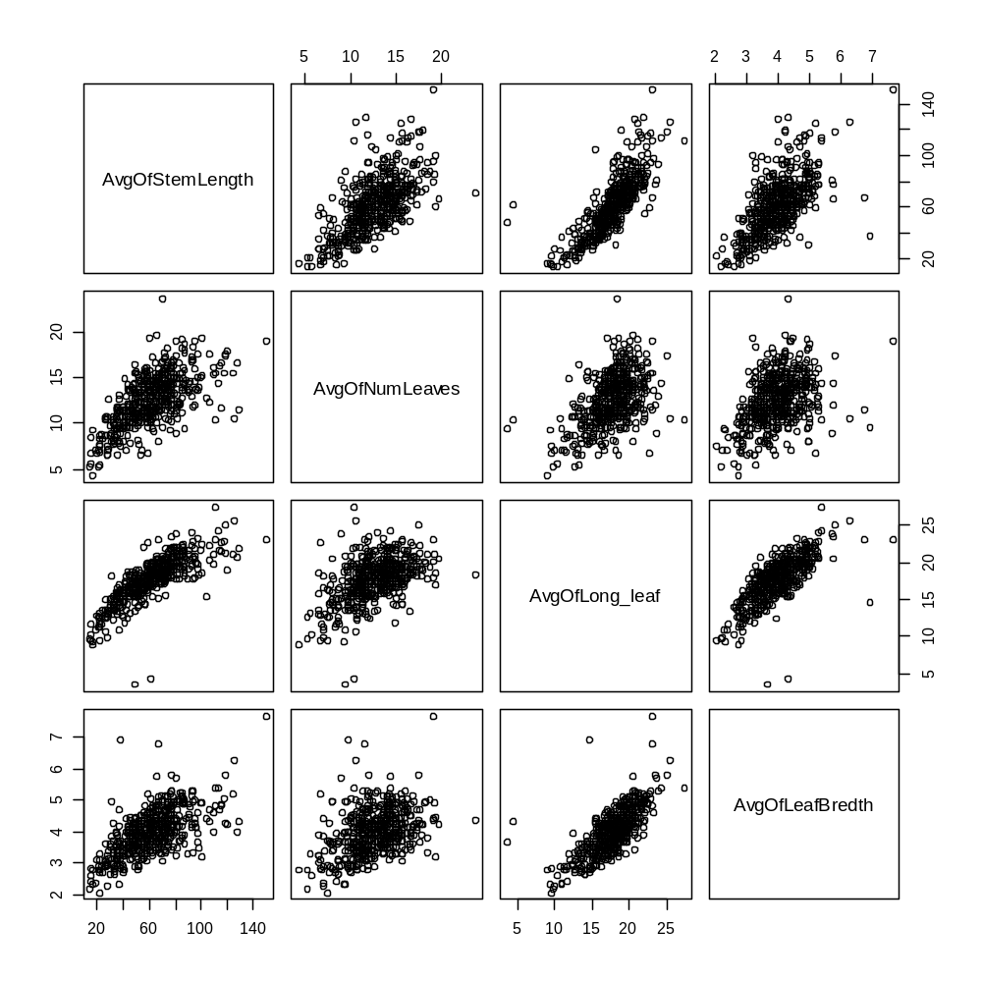

Figure 1. Allometric relationships between different size measures in Afromomum

- Edge and disturbance effects on size variables
The proportion of subplots occupied decreased with distance from edge: 75% at location 1, 62% at location 2, 19% at location 3 and 10% at location 4. In those plots where some A. mildbreadii individuals were recorded, the number of stems was significantly higher in plots closer to the edge of the forest (Kruskall-Wallis chi-squared = 25.583, df = 3, P < 0.001; Figure 2) and slightly but significantly higher in plots in mature forest (Kruskall-Wallis chi-squared = 6.249, df = 1, P = 0.012; Figure 3).

There was little difference in the mean length of longest leaf, leaf number or leaf width per plot between the different locations, though leaves in the interior locations were a little smaller (Figure 2).

Table 1. Descriptive statistics for the number of stems.

Location | mean | sd | min | median | max | Proportion zeros | n
1 | 19.90 | 26.38 | 0 | 11 | 229 |  | 295
2 | 18.67 | 37.66 | 0 | 6 | 300 |  | 192
3 | 11.78 | 18.00 | 0 | 0 | 100 |  | 172
4 | 1.42 | 6.54 | 0 | 0 | 80 |  | 450

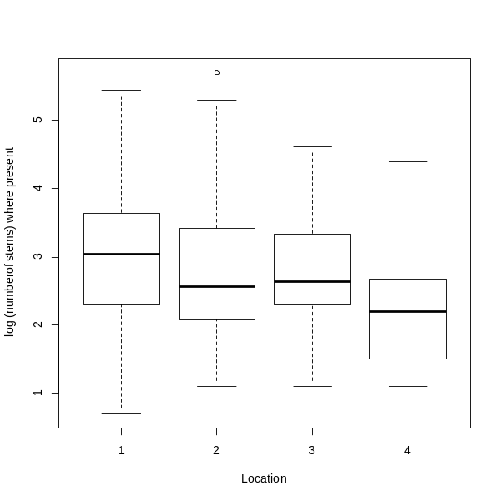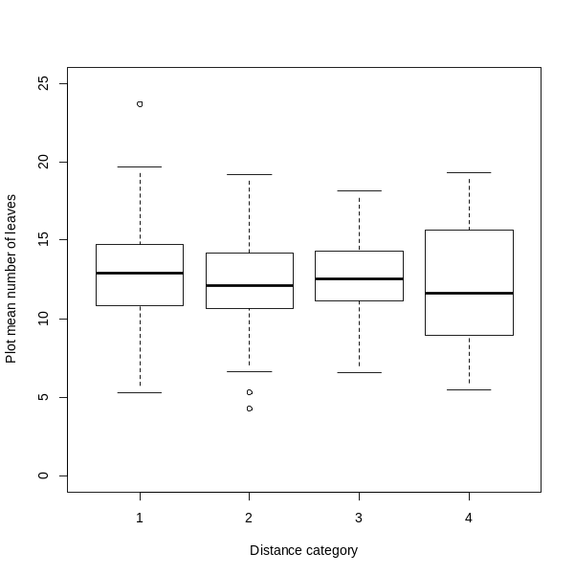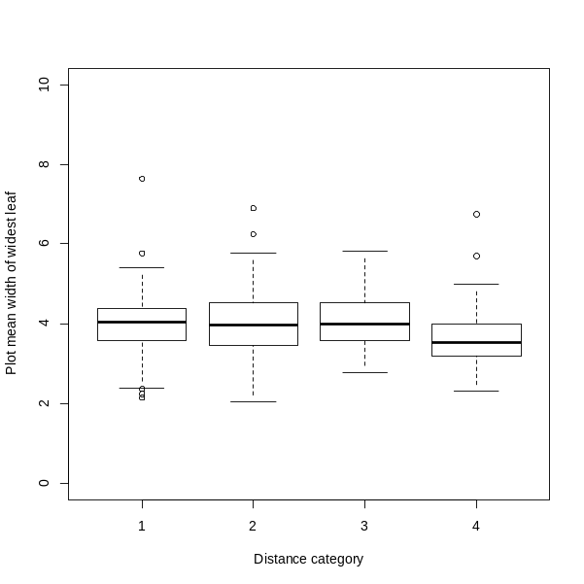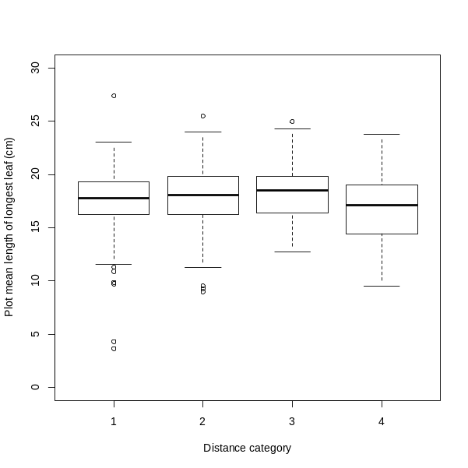

Figure 2. The number of stems in occupied plots, mean number of leaves, width of widest leaf and length of longer leaf for subplots with increasing distance from the forest edge.

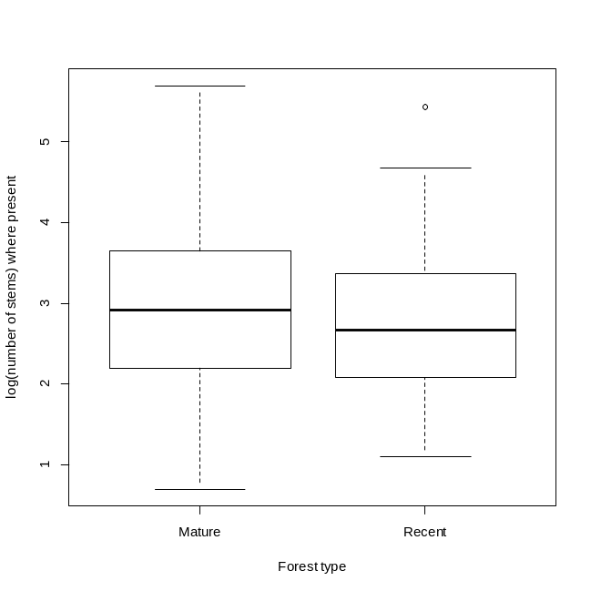
Figure 3. Same as 2 but by forest age.
- Edge and disturbance effects on allometric scaling

There was a significant interaction between forest type and stem length in explaining the number of leaves.

glm(formula = NumLeaves ~ StemLength + Age2class + StemLength:Age2class,
family = quasipoisson(link = "log"), data = total)

Deviance Residuals:
Min 1Q Median 3Q Max
-3.7408 -0.8403 0.0507 0.7639 4.7797

Coefficients:
Estimate Std. Error t value Pr(>|t|)
(Intercept) 1.9952021 0.0190113 104.948 < 2e-16 ***
StemLength 0.0084129 0.0002482 33.897 < 2e-16 ***
Age2classRecent 0.0757889 0.0277708 2.729 0.00638 **
StemLength:Age2classRecent -0.0010563 0.0003706 -2.850 0.00440 **
---
Signif. codes: 0 ‘***’ 0.001 ‘**’ 0.01 ‘*’ 0.05 ‘.’ 0.1 ‘ ’ 1

(Dispersion parameter for quasipoisson family taken to be 1.318882)

Null deviance: 7080.2 on 3430 degrees of freedom
Residual deviance: 4733.7 on 3427 degrees of freedom
AIC: NA

Number of Fisher Scoring iterations: 4

